

**SANYO 4.6 Ton RQ140CXV1**

**Rs. 197,100/-**

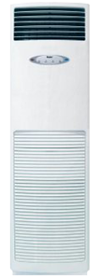

**Product Features**

* evaporator self-cleaning
* Inner brass screw high efficiency exchange heat
* auto mode
* Ultra Thin Design
* High Efficiency Filter

**Specification**

**Type** Wall Mounted Split AC

**Cooling (Btu/h)** 32000

**Voltage (V)** 220-240

**Power Input (W)** 2900

**EER (Btu/W-h-W/W)** 4.7-1.8